Jenkins Assignment 2-pull code from a private GitHub repository and deploy the index.html file to an Apache HTTP server (httpd) using Jenkins.
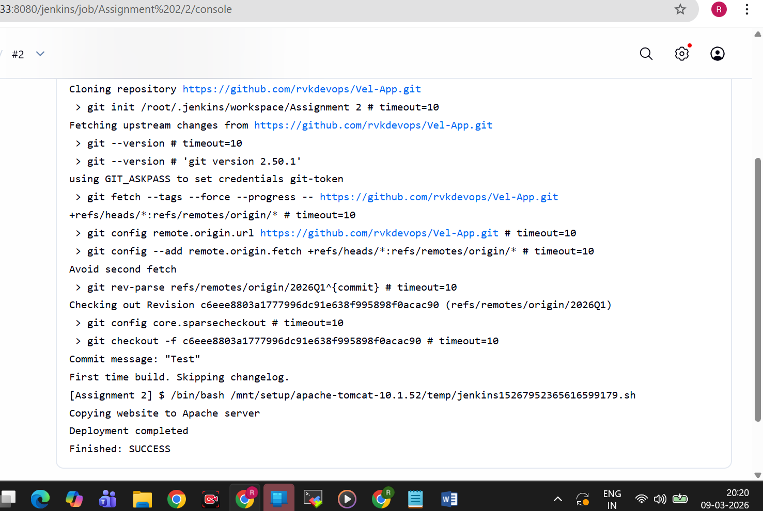

Shell Script-
#!/bin/bash

echo "Copying website to Apache server"

sudo cp index.html /var/www/html/

sudo systemctl restart httpd

echo "Deployment completed"

